Chart Of Edible Flowers
Name | Botanical Name | Blossom Color | Flavor
Anise hyssop | Agastache foeniculum | light lavender | sweet, anise-like, licorice
Apple blossom | Malus spp. | pale pink | delicate floral
Arugula | Eruca sativa | white | nutty, spicy
Basil | Ocimum basilicum | white, blue, pink, lavend | varies by breed
Bee balm | Monarda didyma | red, pink | lemony, minty
Begonia, tuberous | Begonia X tuberhybrida | red, yell, pink, orange wh | crisp, sour, lemony
Borage | Borage officinalis | bluish-lavender | cucumber-like
Calendula | Calendula officinalis | orange, yellow | spicy, tangy, peppery
Carnation | Dianthus spp. | pink, red, lavender | spicy, peppery, clove-like
Chive | Allium spp. | lavender | onion-like
Chrysanthemum | Chrysanthemum spp. | yellow, white | slightly to very bitter
Cornflower | Centaurea cyanus | blue, pink | sweet to spicy, clove-like
Daisy, English | Bellis perennis | white, pastels | tangy, leafy
Day Lily (Lily Buds) | Hemerocallis spp. | yellow, orange, red | sweet, crunchy
Dianthus (pinks) | Dianthus spp. | pink, many colors | clove-like
Fennel | Foeniculum vulgare | yellow | sweet, licorice
Fuschia | Fuschia X hybrida | bi-colors, varied | acidic
Garlic Chive | Allium | white, pink | garlic-like
Geranium | Pelargonium spp. | pink, red, white, peach | varies by breed
Hollyhock | Althaea rosea | pink, white, lavender, red | bland
Impatiens | Impatiens wallerana | pink, many colors | bland
Johnny-jump-ups | Viola tricolor | purple, white, yellow, bi- | sweet to bland
Lavender | Lavandula angustifolia | purple | floral
Lilac | Syringa vulgaris | lavender | lemony, floral, pungent
Mallow, malva | Malva spp. | purple, pink, white | delicate, sweet
Marigold | Tagetes spp. | orange, yellow | spicy to bitter
Nasturtium | Tropaeolum majus | red, orange, yellow | peppery
Orchids |  | purple/white | crisp, warm and soft
Pansy | Viola X Wittrockiana | purple, white, yellow, bi- | sweet to tart
Parrot-beak | Clianthus puniceus | yellow, red, bi-colors | crisp, leafy
Petunia | Petunia X hybrida | many colors | leafy
Pineapple Sage | Salvia elegans | red | sweet, pineapple
Primrose | Primula vulgaris | many colors | sweet to bland
Rose | Rosa spp. | many colors | sweet, aromatic
Rosemary | Rosemarinus officinalis | light blue | sweet, pine-like
Sage | Salvia officinalis | many colors | varies by breed
Scarlet Runner Beans | Phaseolus coccineus | scarlet | nectar, bean-like
Snapdragon | Antirrhinum majus | pink, yellow, white, bi-col | bland to bitter
Squash Blossom | Cucurbita spp. | yellow | nectar, sweet
Stock | Matthiola spp. | purple, white, pink, yell | spicy to sweet, aromatic
Sunflower | Helianthus annus | gold, yellow | leafy
Tansy | Tanacetun vulgare | rust, gold | bitter
Thyme | Thymus vulgaris | white, purple | lemony
Tulip | Tulipa spp. | many colors | crisp, cucumber-like
Violet/Viola | Viola odorata | white, purple | sweet, nectar
Petal Confetti | Many Varieties | multi-colored | eclectic
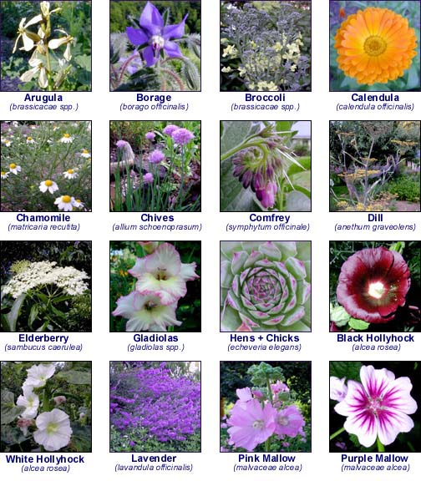
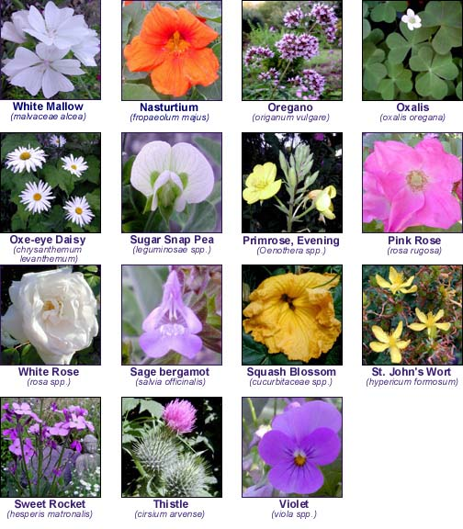
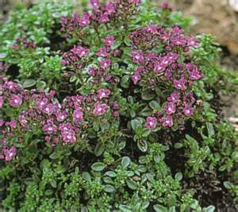Thyme

